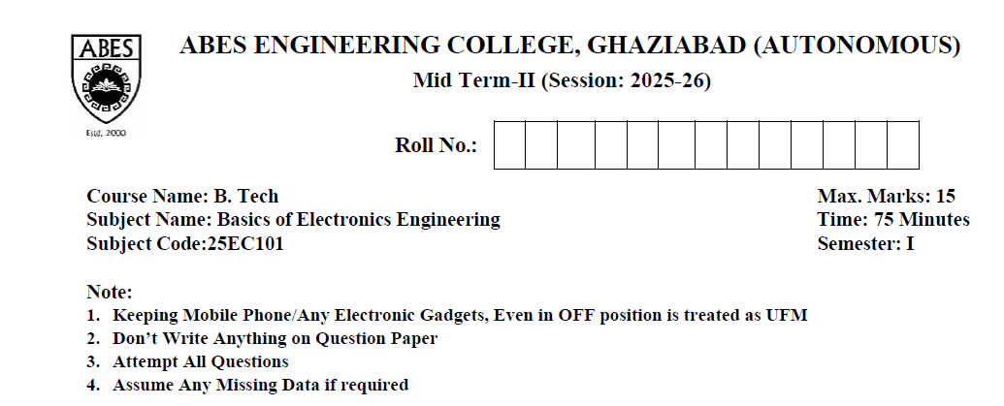
SECTION-A (Maximum Knowledge Level: K2)
- Attempt All Questions (1 x 5)

- Find 2’s complement of the given number 101101.
SOL: To find the 2’s complement:
Find 1’s comp i.e., Invert all bits (1 to 0 and 0 to 1)
101101 → 010010 [0.5MKS]
Add 1 to the inverted number:
010010 + 1 = 010011 [0.5MKS]
Therefore, the 2’s complement of 101101 is 010011.
- State De Morgan’s Theorem.

SOL: Morgan’s Theorem states the relationship between AND, OR, and NOT operations:

- The complement of a product is equal to the sum of the complements: [0.5MKS]
$$(AB)\text{’}=A\text{’}+B\text{’}$$
- The complement of a sum is equal to the product of the complements: [0.5MKS]
$$(A+B)\text{’}=A\text{’}B\text{’}$$

- Consider X = 1010; Y = 1000: Perform X+Y.
SOL:
1010
+ 1000
--------
10010 [1MKS]

- What is Pinch off Condition in FET?
Pinch-off occurs in a JFET/MOSFET when the drain-source voltage (VDS) becomes large enough that the channel near the drain is narrowed or fully depleted. Beyond this point, the drain current (ID) becomes constant, even if VDS increases further. This region is known as the saturation region, important for FET amplification. [1MKS]

- How JFET can be used as Voltage Variable resistor?
A JFET operates as a voltage-controlled resistor when it is biased in the ohmic (linear) region, where I_{D} is proportional to V_{DS}. Therefore, varying the gate-source voltage (V_{GS}) alters the channel width, which changes the drain–source resistance (R_{DS}). Thus, by varying VGS, the JFET behaves like a resistor whose value can be controlled by voltage. [1MKS]

- Attempt Any two Question (Same K Levels) (2 x 2)

- Realize the NOT, AND and OR gates using NAND gate.

SOL:
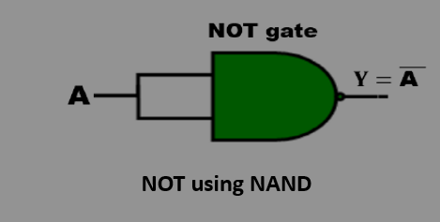 [0.5MKS]
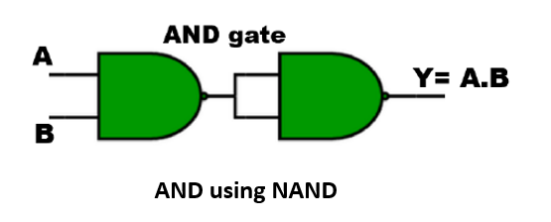 [0.5MKS]
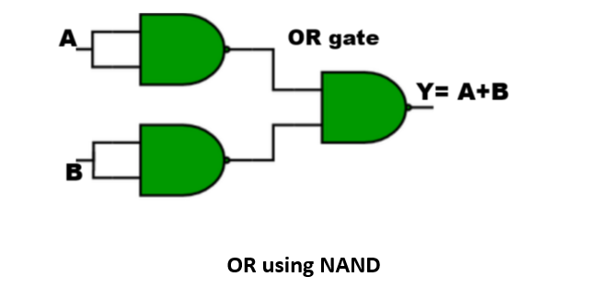 [1MKS]
2. (b) Perform the following:
i) (73.12)₁₀ = ( )₁₆
SOL:
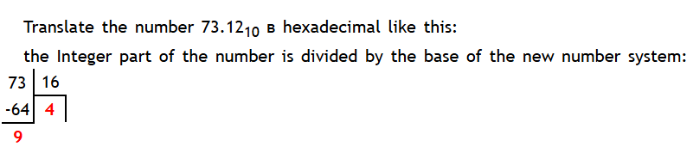
Integer part Fraction part
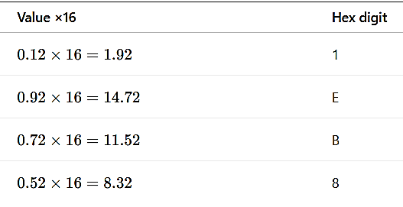
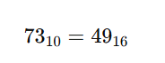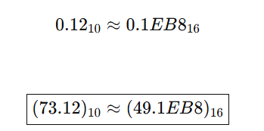
[1MKS] [1MKS]

ii) (750.6032)₈ = (?)₁₆
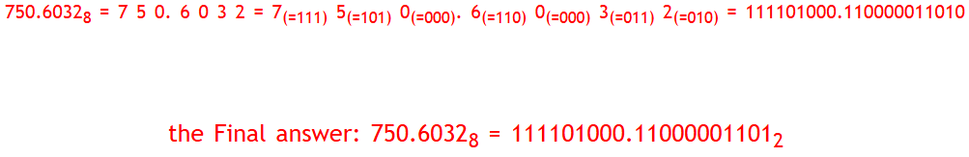
[1MKS]
Write 3-bit number in 4- bit now
Fill in the number with missing zeros on the left if required
Fill in the number with missing zeros on the right if required
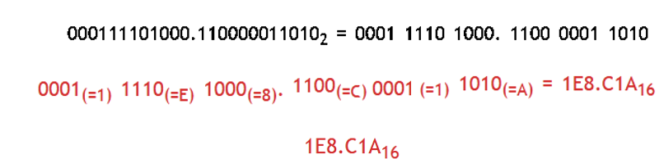[1MKS]
(c). Find the minterms and maxterms for the given expression:
Y = (𝐴̅ + B) (𝐵 ̅+C)
SOL:
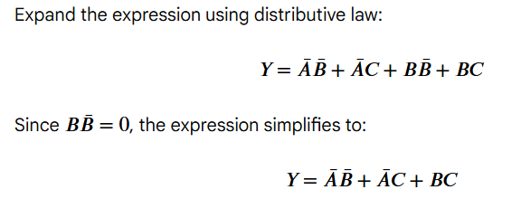[0.5MKS]
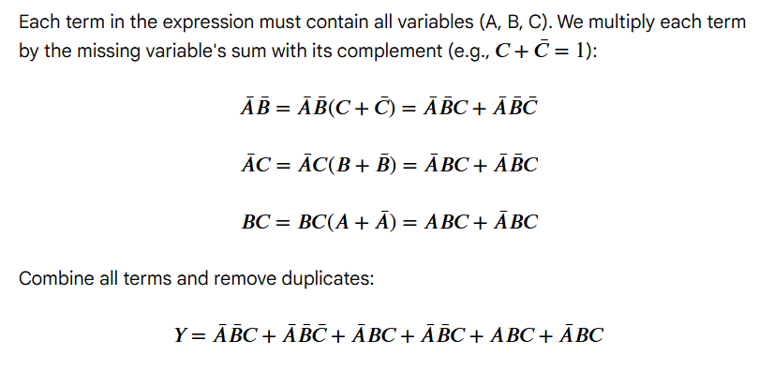[ 0.5 MKS]
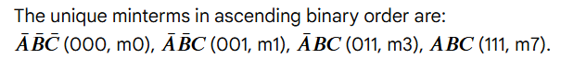 [0.5 MKS]
Minterms: $Y=Σm(0,1,3,7)$ & Maxterms: $Y=ΠM(2,4,5,6)$ [0.5 MKS]

3. Attempt Any one Question (Same K Levels) (3 x 1)
(a)Simplify the expression using K-Map and implement using basic gates.
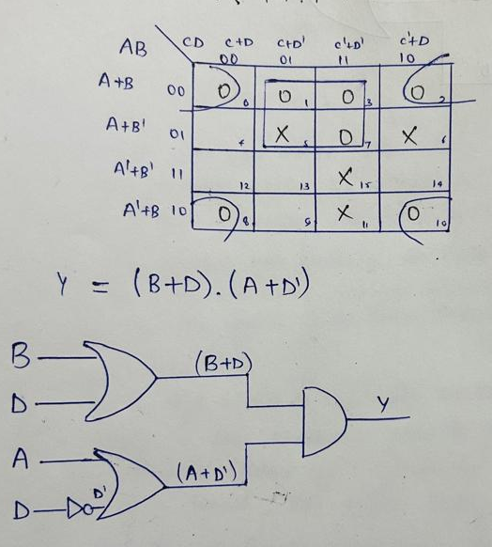
Y = Π𝑀 (0,1,2,3,7,8,10) + d (5,6,11,15)
[1.5 MKS]

[1.5 MKS]

(b)Simplify the expression using K-Map and implement using basic gates.
F (A, B, C, D) = Σ𝑚(0,1,4,6,8,9,11,12,14) +d (3,7)
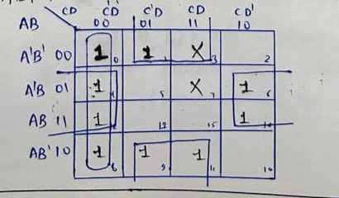[1.5 MKS] 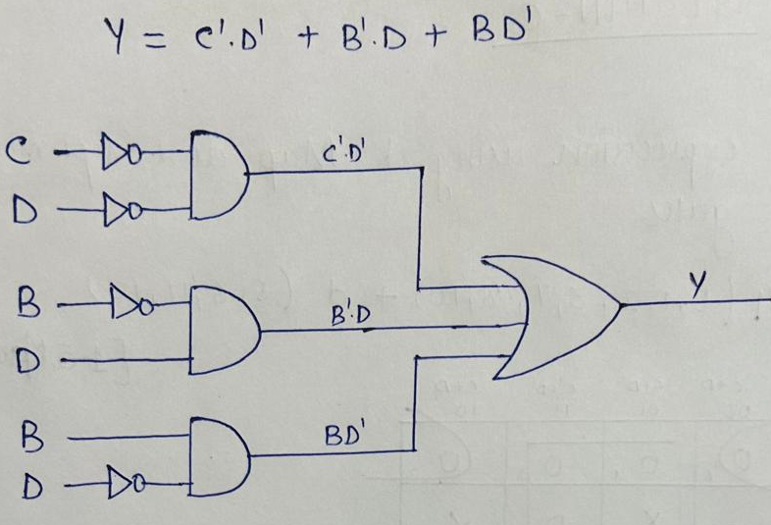[1.5 MKS]
4. Attempt Any one Question (Same K Levels) (3 x 1)
(a)Explain the working of Depletion type MOSFET.

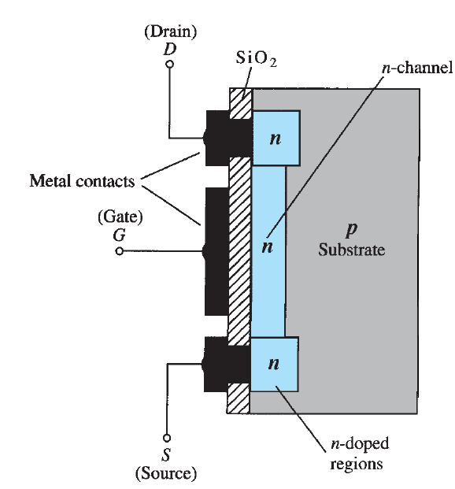[1MKS]
Operating Regions of N-Channel D-MOSFET [1MKS]
Cutoff Region: In this region, the gate-source voltage V_{GS} ≤ -V_{th}. There is no drain current I_{D} = 0 regardless of the value of V_{DS}. The MOSFET is switched off. In this region, the MOSFET remains turned off and there is no drain current ID. When MOSFET is used as a switch, it utilizes this region as OFF-state or opened-state of a switch.
Saturation Region: In this region, the V_{GS} > -V_{th} and the V_{DS} > V_{p} . The MOSFET allows maximum drains current I_{DSS} which depends on the V_{GS.} In the saturation region, the MOSFET allows a constant current between source and drain. It acts as the ON-state or closed-state of a switch. The MOSFET is fully on allowing maximum drain current ID through it.
Linear or Ohmic Region: In this region, V_{GS} > -V_{th} and the V_{DS} < V_{p}. the MOSFET acts as an amplifier. In this region, the current I_{D} increases with the V_{DS} while its amplification depends on the V_{GS} as shown in the VI characteristics. In this region, the MOSFET offers constant resistance that is controlled by the voltage level V_{GS}. The drain current I_{D} increases with the level of the voltage V_{GS}. Therefore, this region is used for amplification.

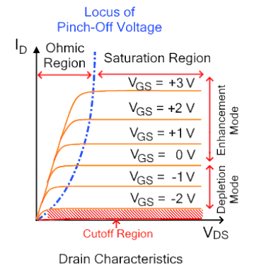 [1MKS]

(b)Explain the working of CMOS as an Inverter.

CMOS (Complementary Metal Oxide Semiconductor) The main advantage of CMOS over NMOS and BIPOLAR technology is the much smaller power dissipation. Unlike NMOS or BIPOLAR circuits, a Complementary MOS circuit has almost no static power dissipation. Power is only dissipated in case the circuit actually switches. This allows integrating more CMOS gates on an IC than in NMOS or bipolar technology, resulting in much better performance. CMOS consists of PMOS and NMOS. [1MKS]

CMOS logic gate operation

- Input is HIGH (logic 1):
  - The NMOS transistor is off, acting as an open circuit and preventing current flow to ground.
  - The PMOS transistor is on, allowing current to flow from the power supply (VDD) to the output.
  - The output is pulled to the HIGH voltage level, or logic 1.

- Input is LOW (logic 0):
  - The NMOS transistor is on, connecting the output to ground (GND).
  - The PMOS transistor is off, blocking the flow of current from VDD.
  - The output is pulled to the LOW voltage level, or logic 0 [1MKS]

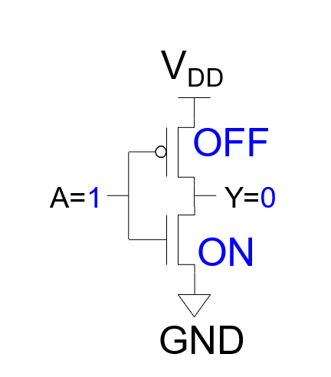 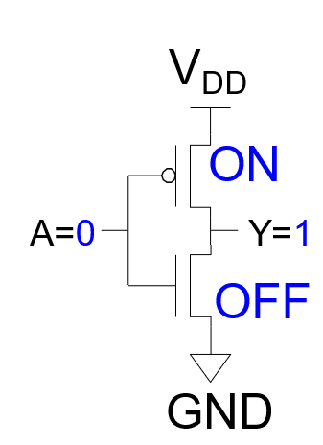 [1MKS]

